### Experiment – No-6

|  |  |  |
| --- | --- | --- |
| Objective: Program to check entered number is prime number or not. | | |
| Scheduled Date | Compiled Date | Submission Date |
| 09-Jan-2021 | 09-Jan-2021 | 10-Jan-2021 |

### Program : A program to check entered number is prime number or not.

### Algorithm

Step 1: Start

Step 2: [ Take Input ] Read: n,I,m,flag.

Step 3: Read the variable n.

Step 4: Given:

m=n/2

Step 5: Apply loop

For(i=2;i<=m;i++)

Step 6: if(n%i==0)

Flag=1

Print “Number is not prime”

Step 7: if (flag=0)

Print ”Number is prime.”

**Program**

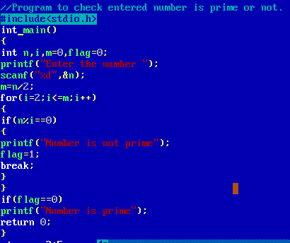

### Output Screen

### C:\Users\WIN10\Pictures\ss2.png